**TRIBHUVAN UNIVERSITY**

Faculty of Management

Kritipur, Kathmandu

An Internship Report

On

**“SOFTWARE DEVELOPMENT IN REDUCT NEPAL PVT.LTD”**

In partial fulfillment of the requirements for the degree of

**Bachelor of Information Management (BIM)**

**Submitted By:**

**Subash Pandey**

Exam Roll Number: 12661/20

TU Registration Number: 7-2-559-29-2020

**Oxford College, Butwal**

June, 2025

# DECLARATION

I hereby declare that the internship report titled **"SOFTWARE DEVELOPMENT IN REDUCT NEPAL PVT.LTD"** is the original outcome of my internship study conducted in 2025 at Reduct Nepal Pvt. Ltd., Sanepa, Lalitpur. This report has been prepared in partial fulfillment of the requirements for the Bachelor of Information Management (BIM) program under the Faculty of Management, Tribhuvan University. It has not been submitted to any other university or institution. I affirm that all sources and assistance have been properly acknowledged, and i take full responsibility for the integrity and authenticity of the contents herein.

.....................................  
Subash Pandey

TU Roll No.: 12661/20

TU Regd. No.: 7-2-559-29-2020

# ACKNOWLEDGEMENT

The successful completion of this internship report would not have been possible without the support, guidance, and encouragement of many individuals. I am sincerely thankful to all who contributed to this journey, both directly and indirectly.

I extend my deepest gratitude to Mr. Punit Jajodia, CEO, and Ms. Rashmita Khatri, HR Manager at **Reduct Nepal Pvt. Ltd.**, for providing me the opportunity to undertake my internship at their esteemed organization. Their commitment to fostering a learning environment enabled me to explore various dimensions of website development, deployment, online compilers, and web socket functionality experiences that greatly enhanced my practical knowledge.

My heartfelt appreciation goes to Mr. Avineak Duwal, Lead Software Engineer and my supervisor at Reduct Nepal, whose expert guidance, constructive feedback, and encouragement played a pivotal role throughout my internship.

I am also thankful to the supportive team at Reduct Nepal. Mr. Biplab Subedi, Scrum Master Facilitator, offered valuable instruction on agile methodologies, while Mr. Yashant Bikram Gyawali, UI/UX Manager, entrusted me with impactful projects that greatly contributed to my personal and professional growth.

I would also like to acknowledge Mr. Aasish Neupane, my academic supervisor and Lecturer at Oxford College, for his consistent support and insightful advice throughout the internship report preparation period.

Finally, i am grateful to my professors, friends, classmates, and family for their constant motivation and belief in me, which has been a continuous source of strength along this path.

**Subash Pandey**

# ABSTRACT

This report, titled **“Software Development in Reduct Nepal Pvt. Ltd.”** highlights the practical experience gained during a three-month internship, focusing on real-world software development tasks across multiple projects. The internship offered exposure to full-stack development, system research, documentation, and internal tool creation within a collaborative and Agile work environment.

One of the key projects involved contributing to a **Challenges Management System**, a web-based platform designed for an educational client to support coding practice through curated challenges in Python and SQL. The system allows administrators to manage problem statements, test cases, difficulty levels, and schema generation for SQL-based problems. Built using **Next.js** and **PostgreSQL**, the platform includes an integrated code editor and focuses on performance, user experience, and secure data handling without storing personal user information.

In addition to this core project, the internship included various other contributions, such as documenting GitHub repositories for **Programiz**, researching ETL tool alternatives (identifying **Dagster** as a potential replacement for Airbyte), automating form submissions with location detection using Google Forms, and actively participating in daily stand-ups and sprint planning. Each activity contributed to strengthening both technical and professional skills, including version control, problem-solving, and team collaboration.

This report outlines the development processes, tools used, challenges encountered, and key learnings gained through this internship experience at **Reduct Nepal Pvt. Ltd.**

TABLE OF CONTENTS

*TITLE PAGE i*

*DECLARATION ii*

*ACKNOWLEDGEMENT iii*

*ABSTRACT iv*

*LIST OF TABLES vii*

*LIST OF FIGURES viii*

*LIST OF ABBREVATIONS ix*

CHAPTER I: INTRODUCTION 1

1.1 Background 1

1.2 Focus of Study 1

1.3 Statement of the Problem 2

1.4 Objectives of Study 2

1.4.1 Objectives of Internship 2

1.4.2 Objectives of System 2

1.5 Limitations of the Study 3

CHAPTER II: INTRODUCTION OF INDUSTRY 4

2.1 Introduction to Information Technology 4

2.2 Introduction of Software Industry 4

2.3 Objectives of Information Technology in business 5

2.4 History of IT in Nepal 5

2.5 Opportunities in Nepali IT Sector 5

2.6 Challenges in Nepali IT Sector 6

CHAPTER III: INTRODUCTION TO ORGANIZATION 7

3.1 Introduction of Organization 7

3.2 Organization Core Value 8

3.3 Organization Selection 8

3.4 Internship Details 9

3.5 Organization Structure 9

CHAPTER IV: JOB PROFILE AND ACTIVITIES PERFORMED 11

4.1 Activities Performed 11

4.1.1 Stand-ups and Sprint Planning 11

4.1.2 Documentation of GitHub Repositories 11

4.1.3 Research on ETL Tools 11

4.1.4 Automated Google Form Location Detection 11

4.1.5 Challenges Management System 12

4.1.6 Reliability Testing 12

CHAPTER V: SUMMARY AND CONCLUSION 13

5.1 Conclusion 13

5.1 Recommendation 13

REFERENCES 15

APPENDIX I 16

Weekly Report Log: 16

APPENDIX II 19

Screenshots: 19

# LIST OF TABLES

Table 3.1: Internship duration details 9

# LIST OF FIGURES

Figure 3.1: Organizational Structure of Reduct Nepal Pvt. Ltd. 10

# LIST OF ABBREVATIONS

API Application Programming Interface

CI/CD Continuous Integration/Continuous Deployment

CRUD Create, Read, Update, Delete

SQL Structured Query Language

DB Database

IT Information Technology

ROI Return on Investment

HR Human Resources

SDLC Software Development Life Cycle

TU Tribhuvan University

UI User Interface

UX User Experience

PPC Pay Per Click

ETL Extract Transform Load

SEO Search Engine Optimization

# CHAPTER I: INTRODUCTION

## Background

The Bachelor of Information Management (BIM) is a four-year curriculum at Tribhuvan University that consists of 60% IT and 40% Management courses. This curriculum prepares students for IT-focused organizational roles through a semester-based framework of 126 credit hours. A three-month internship is an important component of the program, allowing students to apply theoretical knowledge, obtain industry insights, and build critical skills for future employment in IT and management.

An internship is an invaluable learning opportunity that provides students with practical information and hands-on experience in their field of study. It promotes career exploration, skill development, and professional progress, while also benefiting employers by providing new viewpoints and prospective future employees. The internship, which is part of Tribhuvan University's BIM curriculum, allows students to gain firsthand experience with organizational operations, workplace communication, and project coordination. It closes the gap between academic learning and industry practices, increasing employability by improving technical and managerial abilities. This study is based on a three-month internship at Reduct Nepal Pvt. Ltd., which provided firsthand exposure in a professional work environment and practical insights into industry dynamics.

## Focus of Study

An internship is an important step in a student's transition from an academic to professional career. It gives students hands-on exposure with workplace processes, techniques, and real-world difficulties, allowing them to adjust to a professional environment and build critical skills. The study focuses on the following main areas:

* Practical Experience: Internships allow students to apply classroom knowledge in a real-world situation. It provides a forum for students to develop and demonstrate their skills in addition to theoretical study.
* Career Prospects: Gaining experience in an organization opens the door to new career prospects. The knowledge and abilities gained during the internship can have a significant impact on future professional success.
* Industry Exposure: Working in a professional setting allows students to comprehend organizational routines, deal with job pressure, and make key connections that will aid them in their future employment.

## Statement of the Problem

The client, who operates an online learning platform, identified a need for a dedicated system where learners can apply and test their knowledge through practical coding challenges. Existing solutions lacked the flexibility to create and manage challenges with custom problem statements, difficulty levels, test cases, and support for multiple programming languages like Python and SQL. The absence of such a tailored solution was limiting the effectiveness of the client’s learning ecosystem.

## Objectives of Study

### 1.4.1 Objectives of Internship

An internship's main goal is to introduce students to a real-world workplace, which fosters both professional and personal development. It helps students develop their skills, gain practical experience, and explore career options while growing their professional network. The following are the main goals of the internship program:

* To apply academic knowledge to industry operations to obtain practical experience.
* To improve communication and interpersonal skills, which will boost confidence and teamwork.
* To build professional networks and investigate career options in the information systems industry.

### 1.4.2 Objectives of System

The objectives of the system are listed below:

* To provide a platform where the client can create, manage, and organize coding challenges in Python and SQL for learners.
* To allow users to solve coding problems in a secure, real-time environment without storing personal data, while tracking challenge attempts for performance review.

## Limitations of the Study

It was a great opportunity to be an intern in an IT Company. This report is prepared based on the observations, experience of the internship, formal and informal interview with the staff, and the secondary data available on the internet. However, the internship had some limitations.

The main limitations of internship are listed below:

* Could not meet the client on our own, head of companies were engaged in official meetings with the client.
* Research was done on the surface and not in depth due to security policy.
* Due to privacy policy maintained in an organization there was unavailability of adequate information

# CHAPTER II: INTRODUCTION OF INDUSTRY

## Introduction to Information Technology

The information technology (IT) business in Nepal is still in its early stages, but it has enormous potential for growth, investment, and profitability. With the growing use of computers for both personal and corporate purposes, the need for software and IT services is fast expanding. As a result, software companies are fast growing to fulfill market demand. The IT industry includes computer hardware, software development, electronics, semiconductors, telecommunications, e-commerce, and IT services. Both the software and hardware industries contribute to the development, implementation, and administration of IT systems. The ubiquitous availability of IT products and services has increased demand for technology solutions, transforming IT into a crucial driver of worldwide economic growth and employment (Wikipedia, 2025).

## Introduction of Software Industry

The IT industry contributes significantly to e-governance by facilitating access to information, improving operational efficiency, and fostering openness in the service sector. As the world transitions from analog to digital, IT has become an essential element of daily life, influencing how people communicate, work, and learn new skills. The global IT revolution continues to shape economies by driving innovation and increasing productivity in a variety of industries.

Information technology, which integrates computer and telecommunications technologies, allows businesses to efficiently collect, distribute, and manage information, hence increasing competitiveness and knowledge expansion. The global IT industry is worth around $850 billion, with a 15% annual growth rate. While industrialized countries are primarily responsible for IT, efforts should be made to adapt and deploy these technologies in developing countries such as Nepal, aligning with their specific development needs in order to promote economic growth and national advancement.

## Objectives of Information Technology in business

Some of the objectives of Information Technology in business are listed below:

* Improve efficiency and productivity by automating tasks and processes.
* Enhance the accuracy and reliability of data processing and information management.
* Enable better decision-making by providing access to accurate and timely information.
* Facilitate communication and collaboration through networks and communication technologies.
* Enhance the accessibility of information through web-based systems and mobile technologies.
* Provide better customer services through online self-service systems and customer relationship management tools.
* Enable new business models and opportunities through innovative applications and technologies.

## History of IT in Nepal

The growth of information technology (IT) in Nepal has been steady yet significant over the years. Nepal purchased its first IBM 1401 computer for census data processing in 1971, marking the beginning of its IT journey. IT development gained traction in the 1980s, thanks to the founding of organizations such as the Nepal Telecommunications Corporation (now NTC) and the National Computer Center (Techsansar, n.d.).

The growth of information technology (IT) in Nepal has been moderate yet considerable over the years. Nepal got its first IBM 1401 computer for census data processing in 1971, which marked the start of its IT adventure. IT development took off in the 1980s, mainly to the establishment of organizations like the Nepal Telecommunications Corporation (now NTC) and the National Computer Center.

## Opportunities in Nepali IT Sector

The IT sector in Nepal is rapidly growing, offering numerous opportunities for businesses, professionals, and investors. Key areas of opportunity include:

* Software Development and Outsourcing: Nepal is emerging as a hub for IT outsourcing, with companies providing software development, web solutions, and IT services to international clients.
* E-Governance and Digital Transformation: The government’s push for digital governance creates demand for IT solutions in public services, finance, and infrastructure.
* Growing E-Commerce Industry: With increasing internet penetration and smartphone usage, e-commerce platforms and digital payment systems are expanding rapidly.
* Startup and Innovation Ecosystem: The rise of tech startups in areas like fintech, edtech, and AI-driven solutions presents significant growth opportunities.
* Expanding IT Education and Workforce: More universities and training centers are producing skilled IT professionals, fueling industry expansion.
* Cloud Computing and Cybersecurity: Businesses are increasingly adopting cloud solutions and security measures, creating a demand for experts in these fields.

## Challenges in Nepali IT Sector

The following is a list of some of the goals of business information technology:

* Increase productivity and efficiency by automating procedures and tasks.
* Improve the precision and dependability of information management and data processing.
* Give people access to timely and accurate information to help them make better decisions.
* Using networks and communication technology promotes cooperation and communication.
* Increase information accessibility by utilizing mobile and web-based technologies.
* Use customer relationship management technologies and online self-service platforms to improve customer service.
* Use innovative apps and technologies to open new company options and models.

# CHAPTER III: INTRODUCTION TO ORGANIZATION

## Introduction of Organization

**Reduct Nepal Pvt. Ltd.**, established in 2018, is a forward-thinking technology company dedicated to building global products and services through user-centric design and collaborative innovation. The company focuses on simplifying complex tasks such as transcription, translation, and video editing, significantly contributing to job creation in these areas.

Reduct Nepal operates on a strong foundation of core values including **Self-Leadership, Candor, Collaboration, Impact, and Playfulness**. These principles not only define the company's culture but also foster an environment of empowerment and continuous personal and professional growth for its employees.

A distinguishing feature of Reduct Nepal is its deeply client-centric approach. The company believes in working closely with clients throughout the entire project lifecycle to ensure that solutions are both compassionate and precisely aligned with client needs. This collaborative ethos ensures the delivery of high-impact, customized outcomes.

Reduct offers opportunities across diverse domains such as research, marketing, content creation, human resources, engineering, UI/UX design, and digital advertising (including Google Ads). Its versatile work environment and commitment to learning and development were key factors that influenced my decision to pursue an internship here.

The company also engages in a range of national and international outsourcing projects, specializing in website development, attribution setup, SEO strategy, pay-per-click (PPC) advertising, content writing, custom tool development, and quality assurance. Through these services, Reduct Nepal helps businesses generate high-quality leads by crafting persuasive content and tools that support complex decision-making processes.

## Organization Core Value

Reduct Nepal operates with a strong commitment to fostering a supportive, empowering, and dynamic work environment. Its culture is guided by five core values that shape both individual behavior and organizational practices:

1. **Self-Leadership**  
   Encourages individuals to take initiative, seek feedback, and remain accountable to deliver quality work. *(If individuals grow, the team grows)*
2. **Candor**  
   Promotes psychological safety by enabling open and honest discussions, especially around difficult issues, in a supportive space. *(Speaking up is the first step to solving silent problems)*
3. **Collaboration**  
   Emphasizes mutual understanding and teamwork, where individuals consider each other’s needs, goals, and challenges to grow together. *(Together we can go far)*
4. **Impact**  
   Focuses on creating meaningful, positive outcomes for clients, employees, and the broader community leaving a lasting, valuable footprint. *(We exist to shape the larger society we belong to)*
5. **Playfulness**  
   Cultivates a fun and authentic workplace culture where people feel free to express themselves and enjoy their work environment. *(Productivity and well-being go hand in hand)*

## Organization Selection

The **Bachelor of Information Management (BIM)** program emphasizes the development of self-leaders equipped with both technical expertise and managerial insight. In alignment with this academic vision, pursuing an internship at a forward-thinking, reputable tech start-up became a natural and strategic choice.

I choose **Reduct Nepal Pvt. Ltd.**, a company associated with **Parewa Labs Pvt. Ltd. (Programiz)** and **Reduct.Video**. Its emphasis on **Self-Leadership, Candor, Collaboration, Impact, and Playfulness** aligns closely with the personal and professional values encouraged throughout the BIM program.

At Reduct Nepal, I found an environment that allowed me to apply and expand my knowledge in both information systems and project management. The internship offered a hands-on experience in a real-world setting, enabling me to actively contribute to meaningful projects while learning from skilled professionals in the tech industry.

## Internship Details

Following are the details of the internship period:

Table 1.1: Internship duration details

|  |  |
| --- | --- |
| **Organization** | Reduct Nepal Pvt. Ltd. |
| **Address** | Bijaynagar marg, Sanepa, Lalitpur |
| **Position** | Intern |
| **Department** | Tech Team |
| **Internship Duration** | 9 December 2024 – 8 March 2025 |
| **Work Schedule** | 9:00 AM to 5:00 PM (Mon-Fri) |
| **HR Manager** | Ms. Rashmita Khatri |
| **Contact Details** | +977- 9841890918 (HR) |
| **E-mail** | hr@humanaassisted.ai |
| **Mentor/Supervisor** | Avineak Duwal (Tech Lead) |

## Organization Structure

Reduct Nepal Pvt. Ltd. has a structured organization, **Board of Directors** is responsible for strategic oversight and governance. The **HR Team** handles hiring and employee support with required resources, the **Marketing/Content Team** focuses on brand promotion and content creation of Reduct.Video, and the **Transcription QA Team** ensures quality in audio human transcription services. The **Full Stack Teach Team** leads software development of the inhouse product and associated clients projects. As a **Full Stack Intern**, i support this team by contributing to web development tasks and learning practical skills in both front-end and back-end programming.

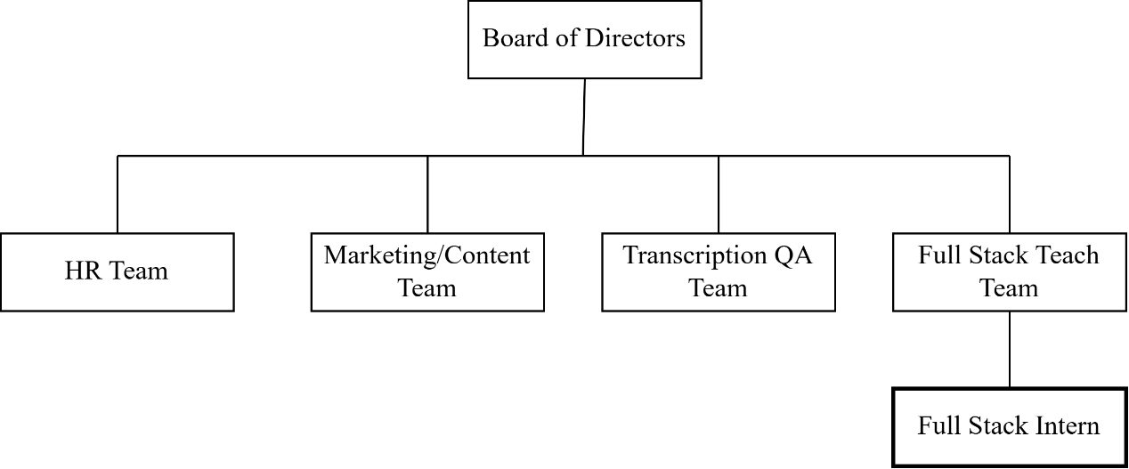

Figure 1.1: Organizational Structure of Reduct Nepal Pvt. Ltd.

# CHAPTER IV: JOB PROFILE AND ACTIVITIES PERFORMED

## 4.1 Activities Performed

During my internship at **Reduct Nepal Pvt. Ltd.**, I was involved in a variety of technical and collaborative tasks that allowed me to apply theoretical knowledge to real-world projects. These activities helped me gain hands-on experience in software development, research, documentation, and project collaboration. Below are the key activities i have performed:

### 4.1.1 Stand-ups and Sprint Planning

Participated regularly in daily stand-up meetings and sprint planning sessions following agile methodology. These meetings helped align team goals and track progress on assigned tasks.

### 4.1.2 Documentation of GitHub Repositories

Contributed to the documentation of more than 6 GitHub repositories of our client **Programiz**, including creating and updating files like **README.md** and **Debugging.md** to improve project understanding and developer onboarding.

### 4.1.3 Research on ETL Tools

Conducted research to find an alternative to **Airbyte**, an open-source ETL tool. Discovered and recommended **Dagster** as a modern and flexible replacement, based on client requirements.

### 4.1.4 Automated Google Form Location Detection

Developed a custom form with automated location detection as part of a **subscription giveaway event**. This was done to enhance user interaction and data accuracy without relying on manual input.

### 4.1.5 Challenges Management System

Worked as part of the tech team to build a **Challenges Management System** that allows administrators to create and manage coding challenges in Python and SQL. Key responsibilities included designing challenge schemas, building front-end components using **Next.js**, integrating a code editor, and handling database operations with **PostgreSQL**.

### 4.1.6 Reliability Testing

To gain knowledge on how online compilers work and how security is handled at an industrial level, I am also involved in the projects of the IT team that is working on an online compiler. We are tasked with improving the reliability of the compiler for more stability and resistance to attacks.

I have been supporting the lead in identifying issues and, learned how the system is implemented. I also learned how tests are written and executed to generate a simple report. I helped to create the report presentable to the clients so they could get insights on the data produced by tests.

# CHAPTER V: SUMMARY AND CONCLUSION

## Conclusion

The three month internship at **Reduct Nepal Pvt. Ltd.** was a highly enriching experience that bridged the gap between academic learning and practical software development. By working in a professional Agile environment, i was able to enhance both my technical capabilities and my understanding of real-world development workflows.

Key contributions included working on the **Challenges Management System**, where I gained hands-on experience with full-stack development using **Next.js** and **PostgreSQL**, while also deepening my understanding of browser-based code execution and database schema generation. Beyond this core project, i was involved in cross-functional tasks such as GitHub documentation, internal tool automation, system research, and ETL tool evaluation—each adding valuable dimensions to my skill set.

Through consistent mentorship, code reviews, and collaborative practices like daily stand-ups and sprint planning, i also learned the importance of communication, time management, and iterative development in a team setting. The internship not only sharpened my programming skills but also prepared me for future roles in a software engineering team.

## Recommendation

To build upon this internship experience and further improve similar internship programs, the following recommendations are proposed:

* **For Reduct Nepal:**
  + Continue assigning interns to real, meaningful projects that encourage ownership and accountability.
  + Introduce short learning sessions or workshops on emerging tools and best practices (e.g., DevOps, CI/CD, or software testing).
  + Offer more structured onboarding documentation to help new interns understand project architecture and workflows faster.
* **For Future Interns:**
  + Make the most of the mentorship and actively participate in team discussions.
  + Take initiative in exploring tasks beyond assigned responsibilities to broaden your exposure.
  + Document your learnings regularly to reflect on progress and identify areas for improvement.

# REFERENCES

(2025, February 17). Retrieved from Wikipedia: https://en.wikipedia.org/wiki/Information_technology

Smith, J., & Johnson, A. (2019). The impact of project management software on team collaboration and productivity. *Journal of Project Management*, 45-59.

Williams, L., & Carter, M. (2020). *The role of project management systems in task allocation and tracking.* Retrieved from https://www.ijpm.com/task_allocation_tracking

Davis, R., & Moore, H. (2020). Project management systems and risk management. *Risk Management in Projects*.

(n.d.). Retrieved from Techsansar: https://techsansar.com/computer-history-nepal/

# APPENDIX – I

**Weekly Log Report:**

|  |  |  |  |  |
| --- | --- | --- | --- | --- |
| **Week** | **Date** | |  | | --- | | **Activities Performed** | |  | |
| 1st | Dec 9 – Dec 13, 2024 | • Onboarded to the team and company processes by shadowing Mentor.  • Gained understanding of existing workflows, tools including Git/GitHub, and development environment.  • Participated in initial daily stand-ups and sprint planning introductions. |
| 2nd | Dec 16 – Dec 20, 2024 | • Conducted research into ETL tool alternatives for AirByte.  • Identified Dagster as a potential solution and compiled preliminary findings and documentation for team review.  • Participated in sprint planning sessions. |
| 3rd | Dec 23 – Dec 27, 2024 | • Developed Google App Scripts to fetch and automate real-time location detection of users for a subscription giveaway event form.• Documented the App Script functionality and setup. |
| 4th | Dec 30, 2024 – Jan 3, 2025 | • Participated in the company retreat at Sky Haven Retreat, Chitlang.  • Started to QA testing for the compiler of the Programiz Pro Playground. |
| 5th | Jan 6 – Jan 10, 2025 | • Observed non-technical individuals completing the "Learn C Programming" course on Programiz.  • Noted areas of difficulty and user experience challenges.  • Compiled and documented detailed feedback for course content and platform revision. |
| 6th | Jan 13 – Jan 17, 2025 | • Began familiarization with client Programiz's GitHub repositories.  • Created and updated README.md files for **“Playground Backend”** repositories to improve project understanding and developer onboarding. |
| 7th | Jan 20 – Jan 24, 2025 | • Continued extensive documentation work on other Programiz GitHub repositories.  • Developed Debugging.md files and other supplementary documentation to aid developers.  • Ensured documentation clarity and accuracy for playground backend repositories. |
| 8th | Jan 27 – Jan 31, 2025 | • Contributed to the initial planning and schema design for the "Challenges Management System" project.  • Researched requirements for managing Python and SQL coding challenges.  • Continued maintenance and updates for existing GitHub repository documentation as needed. |
| 9th | Feb 3 – Feb 7, 2025 | • Worked on front-end components for the Challenges Management System using Next.js.  • Collaborated with the tech team on UI/UX aspects for challenge creation and administration in Figma.  • Documented front-end components and their functionalities in the project’s GitHub repository. |
| 10th | Feb 10 – Feb 14, 2025 | • Integrated a code editor into the Challenges Management System.  • Implemented database operations with PostgreSQL for storing and managing challenge data.  • Updated the project's GitHub repository with backend logic documentation. |
| 11th | Feb 17 – Feb 21, 2025 | • Assisted the IT team with reliability testing for an online compiler project.  • Supported the lead in identifying issues and understanding system implementation.  • Contributed to creating a client-presentable report on test findings and system stability. |
| 12th | Feb 24 – Feb 28, 2025 | • Finalized documentation for all assigned Programiz GitHub repositories (target of over 6 repositories met).  • Completed documentation for contributions to the Challenges Management System.  • Participated in sprint reviews and knowledge transfer sessions. |
| 13th | Mar 3 – Mar 7, 2025 | • Conducted final code commits and pushed all documentation updates to respective GitHub repositories.  • Participated in final internship review meetings with mentor and team. |

# **APPENDIX II**

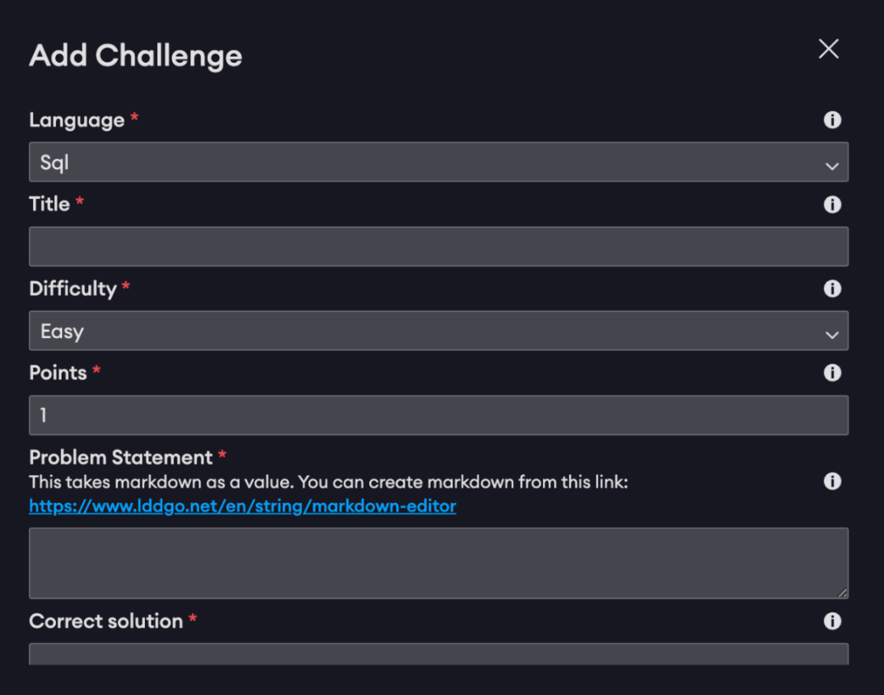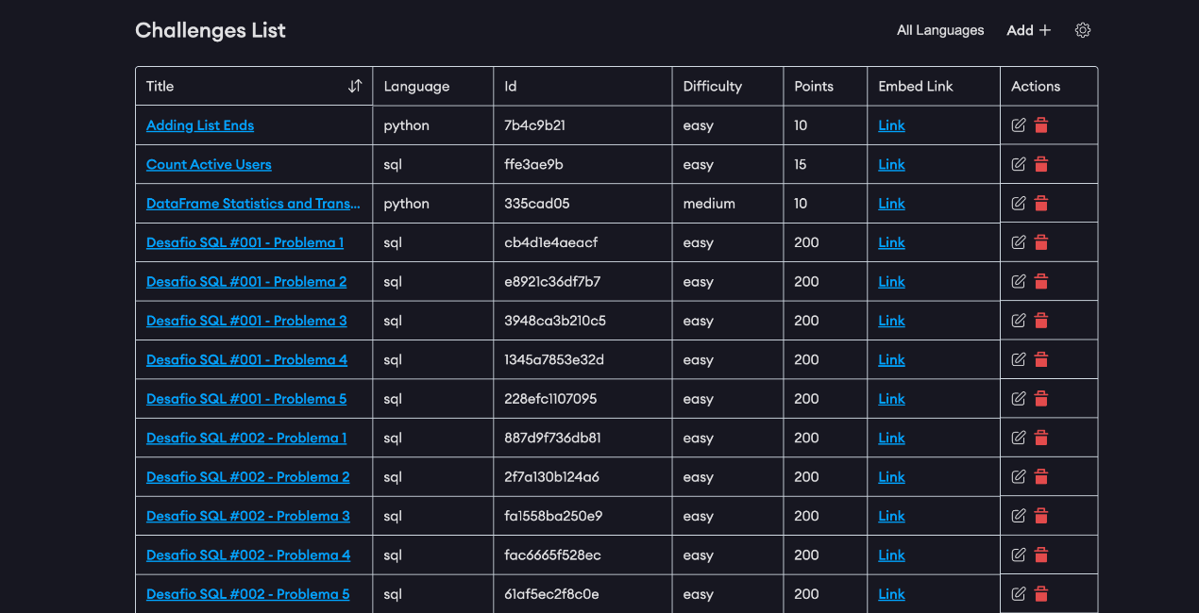Screenshots:  
  
Challenges Lists Management  
  
Challenges Create Form

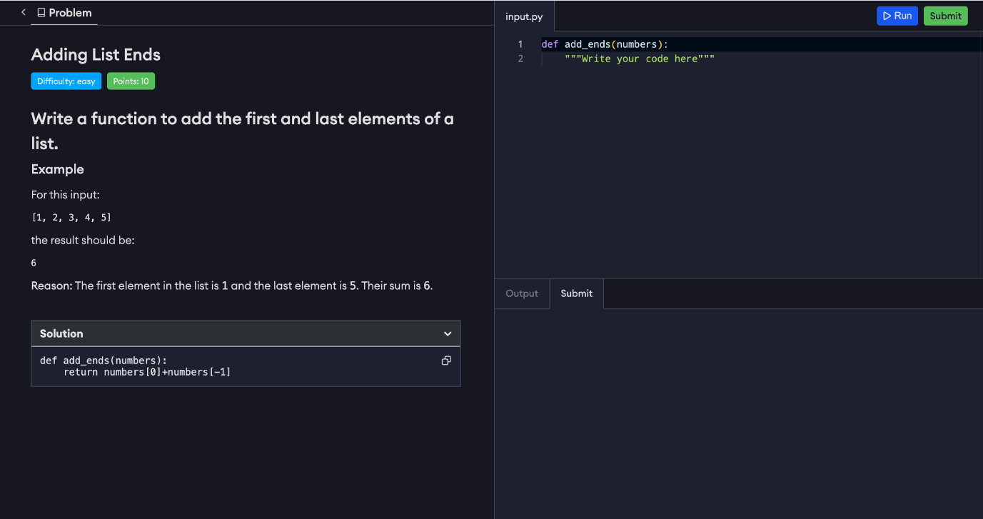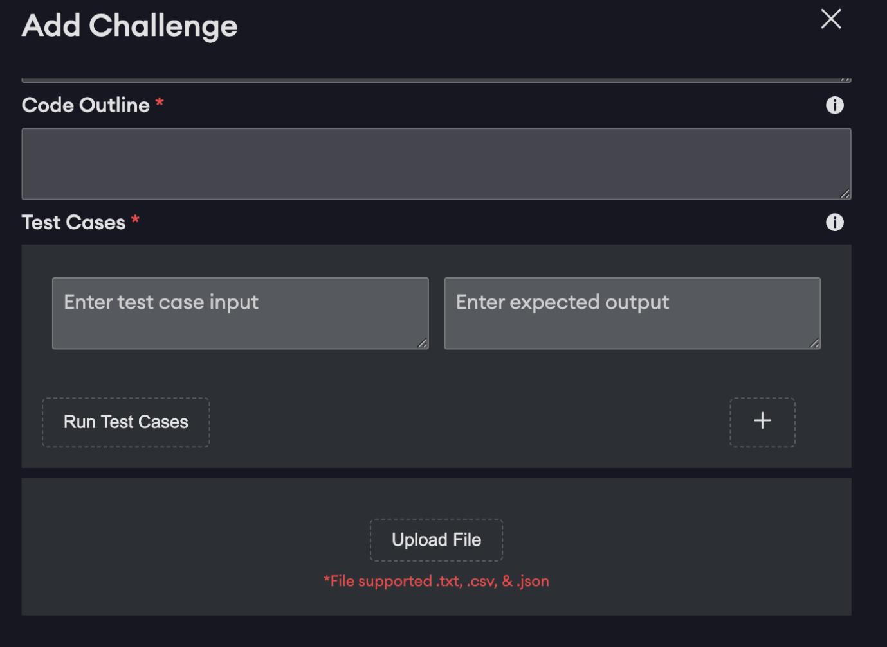  
Challenges Test Cases

Challenges Code Editor